

Practices for Secure Software Report

Table of Contents
Document Revision History 3
Client 3
Instructions 3
Developer 4
1. Algorithm Cipher 4
2. Certificate Generation 4
3. Deploy Cipher 4
4. Secure Communications 4
5. Secondary Testing 4
6. Functional Testing 4
7. Summary 4
8. Industry Standard Best Practices 4

Document Revision History

Version | Date | Author | Comments
1.0 | 6/21/2026 | Dhandeaka Harris-Kearse

Client



Developer
Dhandeaka Harris-Kearse

Algorithm Cipher

SHA-256 is a cryptographic hash function in the SHA-2 family that produces a fixed 256-bit digest, meaning any input data is transformed into a consistent-length output that cannot be feasibly reversed back into the original data (May, 2015). Because it is a hash function, it does not use encryption keys and instead relies on one-way mathematical processing; even a small change in the input results in a completely different hash value, which makes it useful for verifying data integrity at the bit level (Dang et al., 2012). Unlike hashing, secure communication systems such as TLS combine different cryptographic approaches. Asymmetric encryption uses a public and private key pair to securely exchange information, while symmetric encryption is then used for session data because it is significantly faster and more efficient (Rescorla, 2018). Random numbers are often introduced in these systems to generate secure session keys and prevent predictable outputs during key exchange. Historically, older hashing algorithms such as MD5 and SHA-1 were widely used but are now considered insecure due to collision vulnerabilities, where different inputs can produce the same hash (May, 2015). SHA-256 remains a modern industry standard and is widely recommended by NIST for secure applications such as digital signatures, certificates, and data integrity verification.

Certificate Generation
A self-signed certificate was generated using Java Keytool to enable secure communications through HTTPS. The certificate was created using RSA encryption with a 2048-bit key and stored in a PKCS12 keystore file. The certificate was then exported as a CER file to demonstrate that the certificate had been generated successfully. Although self-signed certificates are typically used for development and testing environments, they provide the same encryption functionality as certificates issued by trusted certificate authorities and allowed the secure communication requirements of this project to be implemented and tested.
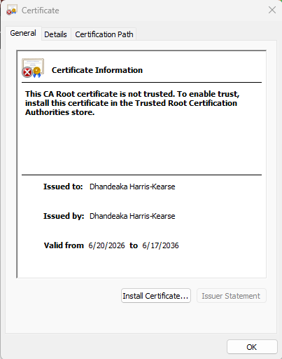

Deploy Cipher
The application was refactored to implement checksum verification using the SHA-256 hashing algorithm. A static data string containing identifying information was processed through Java's MessageDigest class to generate a unique 256-bit hash value. The resulting checksum was displayed through the /hash endpoint, demonstrating the successful deployment of the cipher. Because even minor changes to the original data produce a completely different checksum, this functionality provides a reliable mechanism for validating data integrity during transmission.
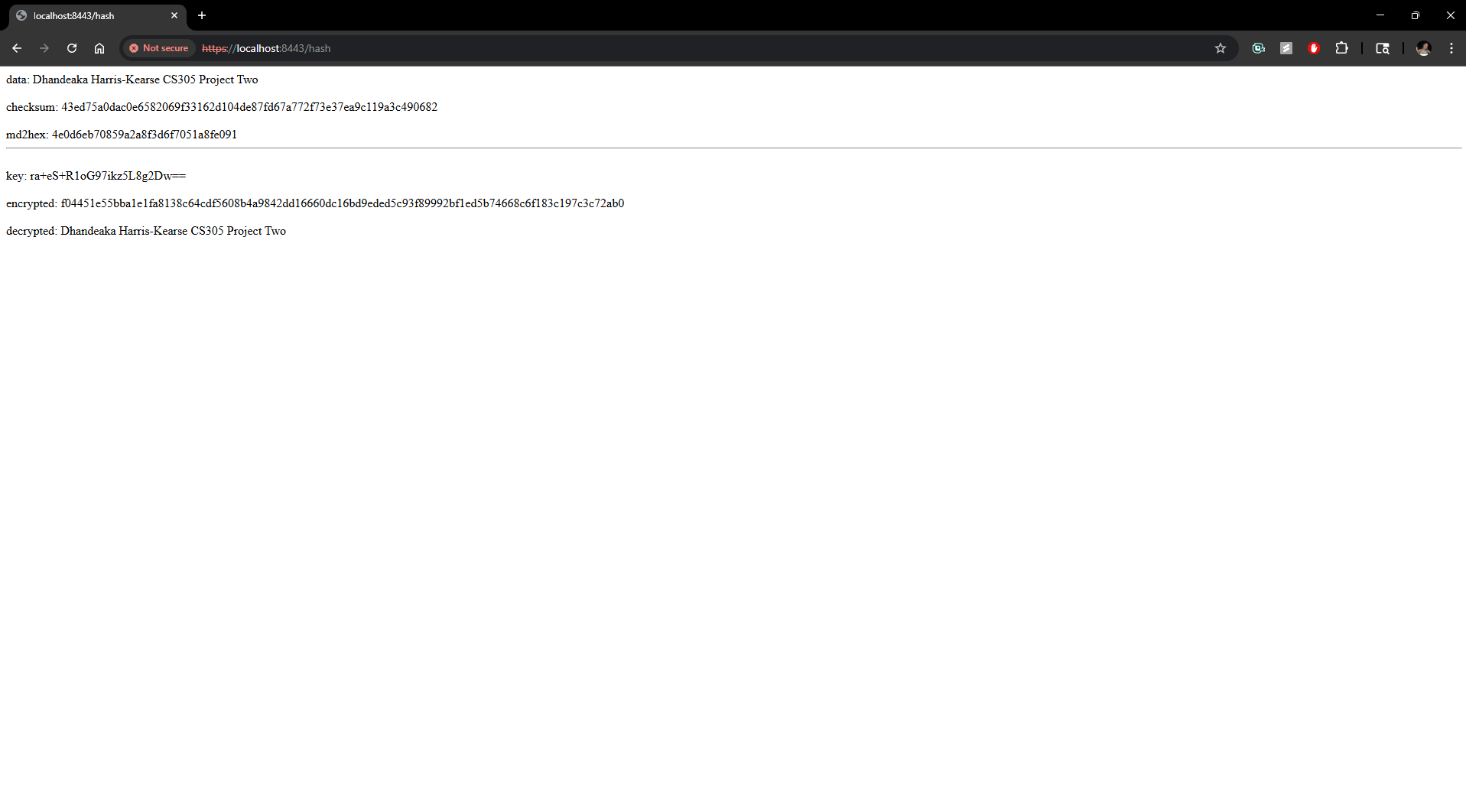

Secure Communications
Secure communications were implemented by converting the application's configuration from HTTP to HTTPS using Transport Layer Security (TLS). The application properties file was modified to reference the generated keystore, specify the certificate alias, and configure the application to run on port 8443. Browser testing confirmed that the application successfully served content over HTTPS. Although the browser initially displayed a warning because the certificate was self-signed, accepting the certificate allowed encrypted communication between the client and server to be verified.
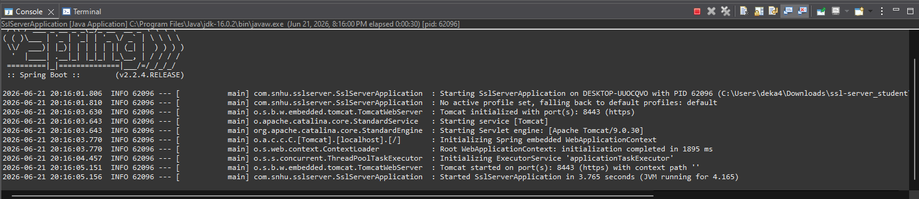
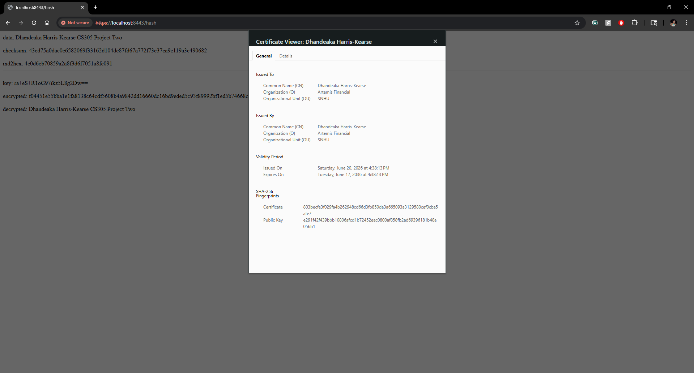

Secondary Testing
Secondary testing was conducted using OWASP Dependency-Check to identify known vulnerabilities within the application's dependencies after the security enhancements were implemented. During the initial scan attempt, the National Vulnerability Database (NVD) returned HTTP 503 Service Unavailable responses, preventing the vulnerability database from updating successfully. To complete the analysis, Dependency-Check was configured to use locally cached vulnerability data by disabling automatic updates. The resulting report was reviewed to determine whether any additional vulnerabilities had been introduced by the refactored code. Findings related to features not utilized by the application, such as AJP connectors and HTTP/2 cleartext communications, were evaluated as false positives and suppressed accordingly. The remaining findings were associated with legacy framework dependencies included in the original project and were not introduced by the checksum implementation or HTTPS configuration.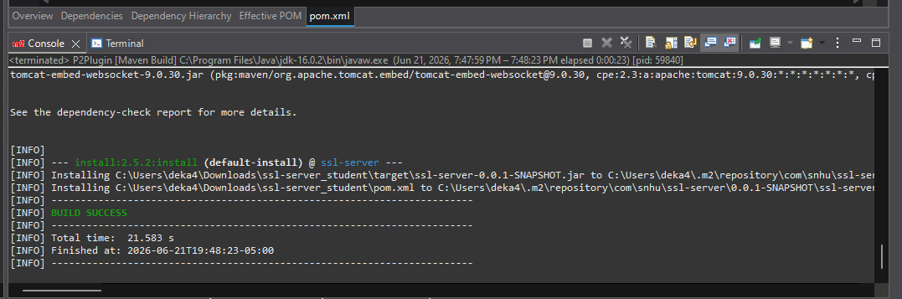
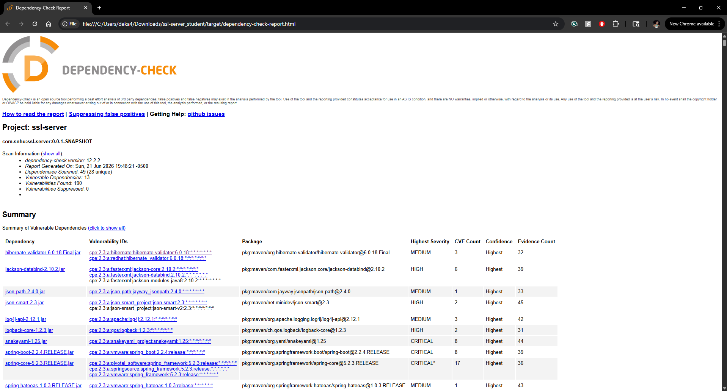

Functional Testing
Functional testing was performed through manual review and execution of the application. Syntactical testing verified that the project compiled successfully and executed without runtime errors. Logical testing confirmed that the /hash endpoint consistently generated valid SHA-256 checksum values for the provided input data. Security testing verified that HTTPS communications functioned correctly using the self-signed certificate and that checksum verification behaved as expected. Together, these tests demonstrated that the refactored application met its functional and security requirements. The temporary NVD service interruption affected only the vulnerability database update process and did not impact the execution or functionality of the application itself.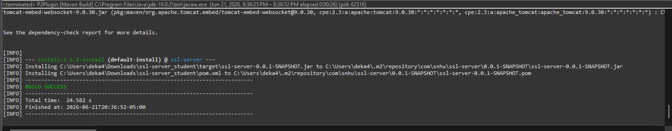
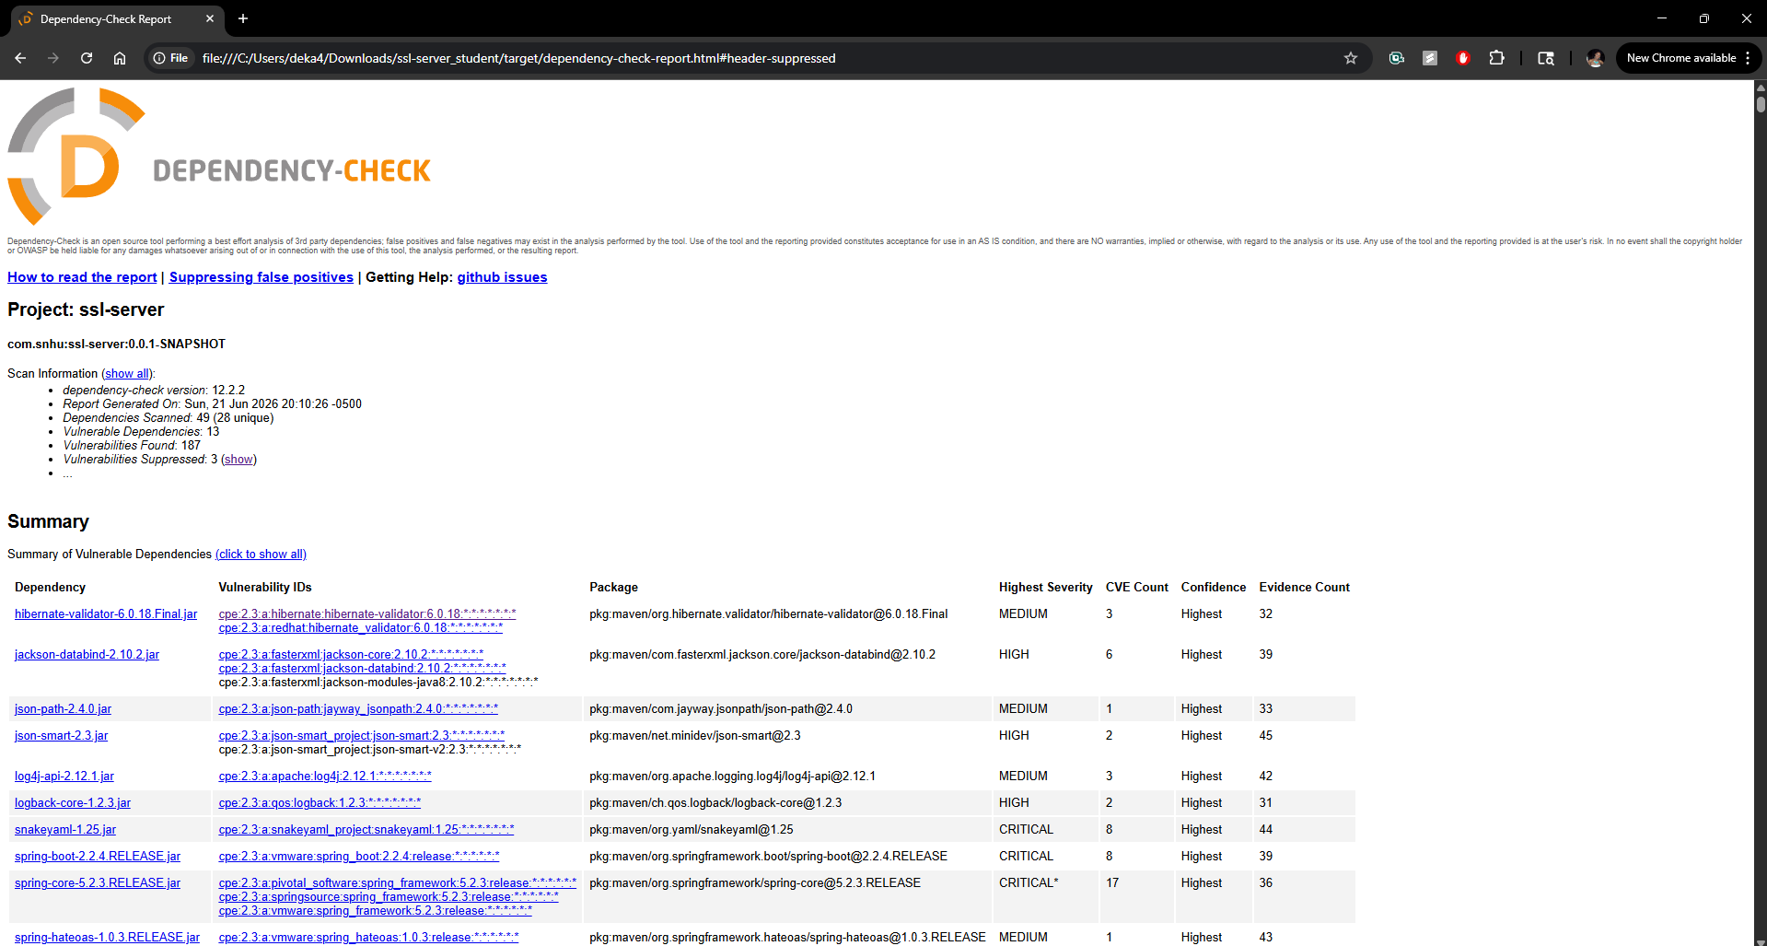

Summary

The Artemis Financial application was successfully refactored to improve both data integrity and communication security. SHA-256 hashing was implemented to provide checksum verification capabilities, enabling validation that transmitted information had not been altered. HTTPS was enabled using a self-signed TLS certificate, ensuring that data exchanged between the client and server was encrypted during transmission. The vulnerability assessment process included identifying potential weaknesses, implementing appropriate security controls, verifying secure functionality, and performing secondary testing through OWASP Dependency-Check. These activities added multiple layers of protection while maintaining the application's intended functionality.

Industry Standard Best Practices

Industry standard secure coding practices were applied throughout the development and testing process to mitigate known security vulnerabilities. The use of SHA-256 aligned with NIST recommendations for approved cryptographic hash algorithms and avoided deprecated alternatives such as MD5 and SHA-1. Secure communications were implemented using TLS to protect sensitive information during transmission. Static analysis tools were used to evaluate dependencies and identify potential risks, while false positives were carefully reviewed to avoid masking legitimate vulnerabilities. Applying these best practices helps organizations maintain customer trust, support regulatory compliance efforts, reduce security risks, and minimize the operational and financial impact of potential security incidents.

References

Dang, Q., Blank, R., & Gallagher, P. (2012). NIST Special Publication 800-107 Revision 1 Recommendation for Applications Using Approved Hash Algorithms. https://nvlpubs.nist.gov/nistpubs/Legacy/SP/nistspecialpublication800-107r1.pdf
May, W. (2015). FIPS PUB 180-4 FEDERAL INFORMATION PROCESSING STANDARDS PUBLICATION Secure Hash Standard (SHS) CATEGORY: COMPUTER SECURITY SUBCATEGORY: CRYPTOGRAPHY. Secure Hash Standard (SHS). https://doi.org/10.6028/NIST.FIPS.180-4
Rescorla, E. (2018). The Transport Layer Security (TLS) Protocol Version 1.3. https://doi.org/10.17487/rfc8446

